CANDIDATE INFORMATION SHEET
On JSC INTER RAO UES AUDITOR

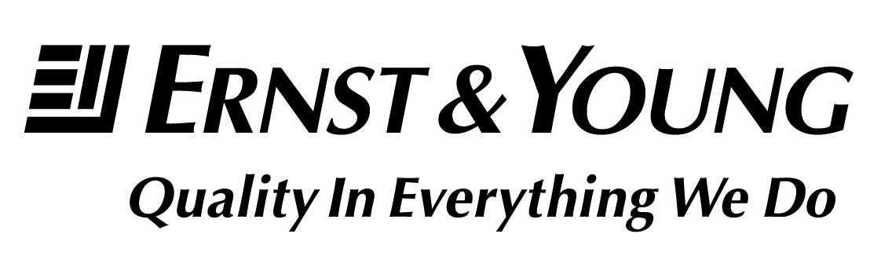
Ernst and Young
Limited Liability Company

Address: Sadovnicheskaya nab., 77, bld. 1, Moscow, Russia, 115035 Phone number: +7 (495) 705-9700
Fax: +7 (495) 755-9701
INN 7709383532
OGRN 1027739707203

The Company is a member of the global Ernst & Young organization providing auditing and consulting services in 140 countries of the world, its staff is more than 144,000 employees.

The Company is a member of the self-regulating organization
Non-Profit partnership of Russian Audit Chamber
(certificate No. 3028 dated May 20, 2009

Membership of the Auditor in colleges, associations, and other professional partnerships (organizations):

1. US Chamber of Commerce (AmCham Russia)
2. Association of European Business (AEB)
3. Russian Union of Industrialists and Entrepreneurs (Employers)
4. US-Russia Business Council (USRBC)
5. Russian-German Foreign Trade Chamber
6. Russian-British Chamber of Commerce (RBCC)
7. Club France
8. Canada Eurasia Russia Business Association (CERBA)
9. International Tax and Investment Center (ITIC)
10. Moscow International Business Association (MIBA)
11. Association Management Resources (AMR)
12. Association of Russian Banks
13. Institute of Internal Auditors)
14. DT-Global Business Consulting
15. International Business Leaders Forum (IBLF) – ("Russia Partnership for Responsible Business")
16. Russian Automobile Dealers Association
17. Independent Directors Association
18 Japan Business Club
19. Japan Association for Trade with Russia and NIS (ROTOBO)
20 National Competitiveness Foundation of Armenia
21. Students in Free Enterprise
22. Green building council Russia

